Module 5 – Privacy, Security & Secret Protection

1. Introduction
This module focuses on identifying security vulnerabilities in an AI-integrated application and implementing best practices to protect sensitive data such as API keys.

2. Project Overview
AI-powered resume analysis system using Python (FastAPI) and Groq/OpenAI API.
Workflow: User → Backend → AI API → Response

3. Identified Security Issues
Issue 1: API key stored in api_key.txt
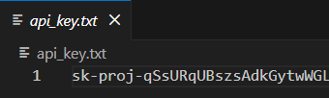
Issue 2: Empty .gitignore file
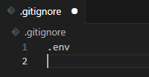

4. Security Fix Implementation
Solution: Use .env file
GROQ_API_KEY=your_secret_key
Updated backend code:
import os
from dotenv import load_dotenv
from openai import OpenAI
load_dotenv()
api_key = os.getenv("GROQ_API_KEY")
client = OpenAI(api_key=api_key, base_url="https://api.groq.com/openai/v1")

5. Git Security Protection
Updated .gitignore:
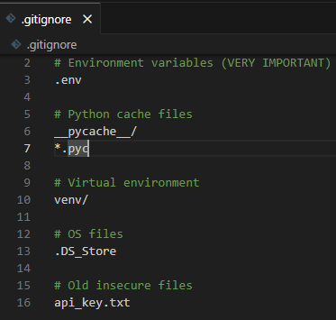

6. Security Improvements
Removed api_key.txt
Used environment variables
Secured backend

7. AI Safe Usage Policy
Do not share API keys
Use dummy data
Review AI-generated code

8. Secure Prompt Examples
Bad: Sharing API key in prompt
Good: Ask error without sharing keys
Bad : Here is my API key: sk-abc123... fix this error
Good : I am getting an authentication error while calling an API. Error: 401 Unauthorized
What could be the possible reasons?
Sensitive data such as API keys, passwords, and tokens should never be included in AI prompts.

9. Risks & Mitigation
Risks: API leakage, misuse
Mitigation: .env, gitignore, backend security

10. Conclusion
Project secured using best practices.

